November 5, 2022, Issue No. 35

Welcome to the thirty-fifth issue of the Bethlehem Lutheran Church Newsletter. This newsletter provides updated communication monthly to all members and friends of Bethlehem Lutheran Church, through November 5, 2022. As a church, strong communication is essential to truly develop and maintain a loving trusting relationship with each other. Articles that follow are submitted by leadership and members that relate information on activities being conducted and planned as we enact our mission of “Called to Invite the Community to Know and Grow in the Love of Christ.”
Message from the Pastor – Submitted by Pastor Tim Feaser
For many years, our thanksgiving tradition was to travel to my wife's parents. They were huge football fans which meant that the whole day was spent watching games. They were such avid fans that they would watch more than one game at a time. They would flip channels and watch two games at once! I was personally never much of a football fan and so I spent most of the day in a fog of confusion, wondering why the team changed the color of their uniforms midway through the quarter.
After several years of this tradition, Sue invited me to plan thanksgiving for a change. "Anything you want, we will do this year," she proclaimed! So, I planned our thanksgiving celebration. I was fairly secretive about my plans, but a few days before, I announced that we would be traveling to New York City to see the Macy's Thanksgiving Day Parade! Then we would see the Christmas show at Radio City Music Hall. Not even one football game and we ate pizza from a food truck instead of turkey. Sue really pushed the envelope when she entrusted me with our Thanksgiving plans, but it left us with some great memories.
There's a parallel to this in our spiritual lives as well. When we allow the Spirit to lead us in a new direction. It takes a bit of faith to venture past our safe traditions, but when we do, it opens new and exciting opportunities. We spent the holiday in a whole new place, and the next year, Sue's parents joined us in New York for the parade! It's really fun to see how things work out. May you be blessed as the Spirit leads you into new places!

Notes from Leadership Team – Submitted by Donna Curran
Congregational Information Meeting
The 2022 Annual Congregational meeting will be held on November 13th starting at 2:00pm or in case of delay the meeting will be held on December 4th at 2:00pm. We will be voting on the Spending Plan for 2023, the Ministry Leaders Call Report for 2023, and proposed changes in the BLC Constitution including the Amendments to the Model Constitution for Congregations approved by the 2022 Churchwide Assembly. The changes to the BLC Constitution and the Model Constitution were discussed in detail at the informal congregational meeting held on Sunday, September 25th. Within the past month, you have received, either by email or postal mail, information pertaining to the changes in the BLC Constitution, along with the Amendments to the Model Constitution for Congregations approved by the 2022 Churchwide Assembly. Changes to the BLC Constitution are necessary to bring the constitution into alignment with the proposed restructuring of the Leadership Team. We ask that you prayerfully consider this information and decide how your decisions at this meeting will ensure the continued future of Bethlehem Lutheran Church.

Please plan on attending this very important meeting. Remember that this meeting is your opportunity to ask any questions you have concerning our church. If you have questions, please contact the Leadership Team President Donna Curran at 237-3312 or any other member of the Leadership Team.

Committee Chairs and Other Needed Assignments
We need members to serve as chairs, especially for the Welcome and Education Committee. Jerry Stanphill has offered to work with Ed on the Property Committee. Diane Wetternach has also offered to help with any committee. The congregation does not need to vote on the chairs and there is no set term of service.

John Goodrich is taking a break for now with power point. He is willing to provide training. So far, Mary Kay has
volunteered to do power point for New Song and Dan Curran has been covering for Traditional Service. Lynn Suwala and Judy Friel are also willing to help. Maurice Bell said he would do it if necessary. If we don’t have someone, then we will use bulletins.

Financial Status for 2022 and 2023
Thank you all for your generous gifts which has brought us Pledges & Regular Giving at 107% of budget with average weekly attendance at 29 per service. Praise the Lord!

Expected income pledged and non-pledged envelop giving in 2023 is $88,492. This is greater than 2022, and other income has provided an expected total income of $100,288. Spending plan details have been sent out to the congregation and will be discussed and voted on during the upcoming annual meeting.

Facilities Status
- Dishwasher- Repairs are completed.
- Lighting - Lights outside of Cauble Hall are repaired and are now working, however, the light in the parking lot is not working. Sofit lights are on a timer. The fluorescent lighting in the front facing Timberlake Road is out and Canada Electric is sending an estimate

- Outside Cross: We have a written proposal from Steve’s Signworx to prime, paint and install the aluminum cross on top of the existing painted blue cross and to cut off the bottom of the aluminum cross to fit the existing wood cross. The cost will be $987.00 with a 50% deposit of $493.60 required at signing and $493.50 upon completion. Toby Murphy is working with Signworx on this project.

- Projections of building needs for 2023: The windows in Cauble Hall need new putty. They may need to be replaced. The shades need to replace with curtains in Cauble Hall. Floors need stripping and baseboard needs painting. SDA will be asked to assist with some of the repairs/updates in Cauble Hall. To date many items have been repaired, including adding the vapor barrier to the old choir room, dusk to down lights in the courtyard and locks on doors.
Future Service Plans and Schedule
- Thanksgiving Service: The service will be held on Nov. 20th at 3:30 pm at our sanctuary. It will be a joint service with Bedford Lutheran Church. A desert will follow where pumpkin and apple pies will be provided by both churches.
- Advent Service: Adult Bible Study will begin on Wednesday, November 30, and end on December 20. The time will be 6:00 – 7:00 pm. Holden Evening Prayer Service will begin at 7:10 pm.
- Christmas Eve Service (Saturday, Dec. 24): Bedford has their service at 5:00 pm. Bethlehem usually has their service at 7:00 pm. These times are not finalized.
- Christmas Day Service (Sunday, Dec. 25): Lessons and Carols. (Information is not finalized)

Community Outreach Plans
The Community Ministry Team met to discuss planning for the remainder of 2022. We are no longer doing the Angel Trees for residents at Bedford Nursing. The team is planning to send ornaments to shut ins for Christmas. The children will send Christmas cards. We are also going to get a small number of angel tags from Elves for Elders this year. This program provides gifts for people in the area who do not receive any gifts. Kick off for Operation Christmas Child was October 9th. Karen Murphy will send out information for collection of items for Backpacks for the Homeless in November. A meeting is scheduled for January 6th to discuss plans for spending funds from the HHCC and Betty’s Pantry.

Grow/Education Report
- The children are spending about 45 minutes after church on crafts related to the sermon.
- For adult Sunday school activity, several video presentations are being considered such as “The Chosen series.”
- During Advent Event, Pastor Tim will be using the Bethel series. The Advent series will begin on November 30 and go from 6:00 -7:00 pm. There will be four seminars. The Advent Service will begin at 7:10pm.
- The “Lost and Found” gathering at Eagle Eyrie takes place in November and “Winter Celebration” is scheduled for January 27-29, 2023. “7th Day” is scheduled for March 4-5, 2023. Currently, we do not have any youth old enough to attend these events. Movie nights and a lock in are being considered for some of the activities that could be offered in the future.
Invite/Fellowship Report
- Thanksgiving Joint Service with Bedford: November 20th at 3:30 pm. Pastor said that Bedford Lutheran Church will bring apple pie and Bethlehem will furnish pumpkin pies and cool whip.
- Welcome Trifold: The welcome brochure is being prepared. Needed pictures from the Aug. 28th event are available, and we have pictures from VBS. New picture(s) of the front of the church are still needed. We need to include information about the alternating traditional and contemporary services.
- Update on Shut Ins: – Carolyn Robinson talked with Sherry Will who said that Della is now in a transitioning phase as her dementia has progressed. The Pastor will contact Sherry.

Stewardship
- Financial Faith Promise and Time/Talent Sheets were consecrated during the Sunday service on October 30th. Results of the pledged and expected non pledged offerings was very positive, see discussion above under Financial Status for details.
- In recognition of the generous response in time, talents and treasure to the year-round stewardship program, mini loaves of bread were made and distributed by Karen and Toby Murphy to members on October 2.
- Kick off for Operation Christmas Child was October 9th. A video was shown of Wanda Goodrich interviewing a local OCC rep. Shoeboxes will be available for pick up with instructions on selecting items for the box. BLC’s goal is 40 boxes for 2022. Shipping costs for each box is $10; and we are collecting funds for shipping during the month of October. Boxes are due back on Sunday, November 6.
- In 2023, a new program of interviewing people in community to ascertain what significant needs exist in our community. The Pastor will ask people in the congregation to approach unchurched members to find out what people in the local area think that the church can do to make things better. This information could be helpful when we are planning ministries. For example, a church in Arizona did this exercise and found out that potty training was a big issue, and they offered some educational sessions on this topic. The church became known as the church that cares. Suicide was also a big concern. The church formed a suicide survivors’ group. Pastor said that he and Toby would like to meet with about 15 people. More details to follow. This will take place in January or February.

ELCA Social Statements – The ELCA Social Statements various topics such as abortion, human sexuality, and similar topics are available for check out in the Narthex. Leader Guides are available also.

Our Church Life and Mission
Stewards of God’s Love – Submitted by Toby Murphy
A Thanksgiving story of gratitude:

Thanksgiving was a busy time in the Johnson family. Mrs. Johnson was up way before sunrise tending to an enormous turkey that was already filling the house with a delicious aroma. Becky, her 8-year-old daughter bounded down the stairs excited for the Macy’s Parade and time with Mom and Dad. All this holiday spirit ended when Mr. Johnson descended the stairs in a foul mood and announced he was going to the office to close a contract that was due the next day. He began to put on his coat and made a sideways glance at his wife who was throwing daggers at him with her eyes. What was worse was the look in Becky’s eyes which were beginning to fill with tears. Mr. Johnson pushed this scene out of his mind and walked out the door with a dark cloud of guilt and regret over his head.

As Mr. Johnson got out of his cab, paying the driver, he started down the city sidewalk to the tall building where his office was located. As he turned the corner, his progress was halted by a ragged old man and a small dog seemingly camped out in front of the entrance to his office building. The man was sitting on a moth-eaten blanket softly playing a beat-up guitar with the dog resting by his side. An empty guitar case with a single dollar
bill was close to the camping pair. “What in God’s name are you doing here?” the man said gruffly. The old guitar player looked up at the angry well-dressed man and said: “Sir, my dog and I come out here every morning to greet the sunrise. I suppose we have missed each other because I try to leave before the working folks such as yourself come”. The beggar was genuinely apologetic and continued. “As you can see my partner and I don’t have many possessions, but since we have the beautiful sunrise on this Thanksgiving Day I thought it would be nice to spend the day here with my dog to greet some folks with a holiday tune and thank God for his blessings.

The man, who was about to angrily give this ragged beggar and his ratty dog a verbal lashing stopped when the old fellow said. “Sir I am very sorry to upset you. I did not suspect I would be seeing anyone who needed
to get into this building this morning” So, the old man began to roll up his blanket and put his guitar back in its case. As he began to walk away giving the man access to the building, the beggar turned to the executive
and said, “sir may I ask you WHAT ARE YOU DOING HERE?” Mr. Johnson felt like he had been hit with a lightning bolt. What was he doing here? While he was ranting at a helpless and apparently homeless old man and his dog, the real blessings of his life were elsewhere and missing him. On a day reserved for giving thanks for blessings he was not even home with the two most important gifts God had given him, his wife and his daughter. As he hurriedly flagged a cab, he could not get home fast enough. Sitting in the vehicle’s back seat, he silently thanked God and the old guitar player in front of his office building.
Stewards of God’s LOVE
Nurturing the Blue Thread of Hope by Bringing Hope toOthers
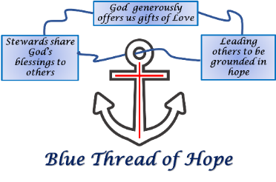

Wicker Basket Schedule for Reminder of 2022 - Submitted by Carolyn Robinson
Capital Improvement – 3rd Sunday of each month
November – Blessing Bag Supplies
December – Kids’ Haven

Elves for the Elders – Submitted by Susan Baughman
The Central Virginia Alliance for Community Living (CVACL) sponsors Christmas gifts for 650 elderly members in the counties of Amherst, Appomattox, Campbell and Bedford and the City of Lynchburg. Each person is allowed to name three gifts that they would like, and those wishes are printed on a paper ornament which is placed on one of the Christmas trees around the area. Gift requests are moderate in price, although there might a special request such as a shower seat which could cost more. The person gifting has the option of fulfilling as many of the requests as they want or adding a few extras. Many of the recipients are homebound or have no family. Most of the gifts are delivered through the CVACL Meals on Wheels program along with a bag of fruit and nuts and a card made by the Boys and Girls Club. Last year, CVACL also provided a complete Christmas Dinner box to 30 of its patrons for whom there would have been nothing otherwise.

This year, the Bethlehem Community Team decided to offer five of these ornaments to members of the congregation. The ornaments will be on the trees Nov 19th, and we hope to have them at church on the 20th for distribution. The return date is Dec 10th. The gift can be returned to the location of the tree, or brought back to the church to be picked up by CVACL, or dropped off at their offices on 12th St. The gift can be wrapped or unwrapped. If you want to help provide a gift, but don’t want to shop, CVACL has made it easy to donate money for gifts on their website.

More information will be available in November, but for any questions at this time or if you wish to have an ornament, contact Carolyn Robinson or Susan Baughman. CVACL offers 32 different services to those over the age of 60 or disabled over age 18. Their website is www.cvacl.org if you want to see if they can help you or if you can assist in some way.

Blessing Bags for the Homeless – Submitted by Karen Murphy
We will be collecting items to fill 20 Blessing Backpacks for the homeless in the Central Virginia area during the month of November. As we approach Thanksgiving and realize the endless amount of things, we need to be grateful for, we often take for granted the items that others don’t have that are basic necessities. We will be making 10 female backpacks and 10 male backpacks. These backpacks will be divided between The Salvation Army and The Lighthouse Ministry in downtown Lynchburg. A sign-up sheet will be available during the entire month of November and the donations are to be returned by Sunday, December 4. Ann Johnson has once more written a Thrivent grant and we will purchase socks, gloves and flashlights if money allows. More information will come later about the packing of these backpacks. In advance, thank you for your generosity. Bethlehem Lutheran always steps up to help those less fortunate.

Grief Package Ministry Offered by Thrivent – Submitted by Susan Baughman
Hopefully you are aware of some of the benefits offered to Thrivent members. In addition to the two $250.00 grants offered each year to each member, Thrivent provides grief resources to keep or to share. As well as books related to the grieving process, there is a care package for parents who have experienced a miscarriage, a stillborn, or a child who only lived a short time. The package was redesigned in 2018 to include a full-size blanket and a devotional book entitled Grieving the Child I Never Knew, which was written by a Thrivent client who had experienced this heartbreak years earlier. Because this package is offered free to Thrivent members, I ordered one and brought it to church. In showing it to the first person I met, she mentioned that someone she knew had just suffered a miscarriage, so the blanket and book went to her friend. Was that God’s timing? Sure seems like it to me.

We are an older congregation but that does not mean that our family members or others might not appreciate this care package if need be. Someone suggested that several members could order care packages and keep them on hand at the church. Thrivent members can request materials once each calendar year. If you have the Fall 2022 Thrivent Magazine with the chess set on the front, the article is on page 3. The package can be ordered at thrivent.com/condolence.

In addition to the care package, if the parents are Thrivent clients, they can apply for a $5000.00 grant to be used however they wish.

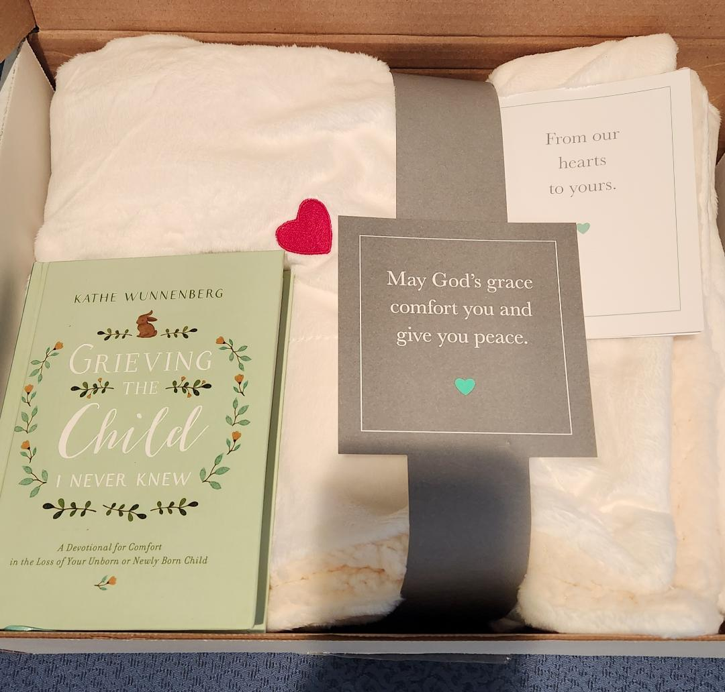

Thrivent Choice Dollars – Submitted by Susan Baughman
If you have Thrivent Choice Dollars, don’t forget to designate where you want the money sent, whether it be Bethlehem or some other charitable organization.

Chase the Chill – Submitted by Susan Baughman
As seen in the video during the August 21st service, Chase the Chill provides a much needed and appreciated source of warmth to some of the neediest people in our community. Groups and individuals around town supply handmade or new items such as hats, scarves, gloves, socks, etc. that are hung from clotheslines, railings, and trees for anyone to take. It is not necessary to answer any questions or provide proof of need. A Thrivent Grant has been approved for the purchase of gloves. A hamper is in the Narthex for any items that you wish to contribute. The date of the distribution is Thursday, January 5th, but the final date for collection at Bethlehem is Sunday, Dec 18th in order to give time to wash all items. If you have any questions, contact a member of the Knitters and Prayers.

Scrapper Update – submitted by Claudette Engelke
Scrappers, consists of 8 very dedicated ladies and one man, who meet on each Thursday morning at 9:30am and remain there to 11:00am. This year they maintained that schedule even through the summer months. So far this year, the Scrappers have distributed 122 quilts to Parkview Community Mission, Child Protective Services of Lynchburg, and Bedford Community Nursing Home. The typical comments of those who received the quilts are one of sincere appreciation. Thanks to Thrivent grants, your wicker basket and other material donations, we would not be able to provide the care and love these quilts provide.

Lately we have not been keeping up with needed solid color sheets, because the price of the sheets we buy from Goodwill have risen from $1 to $3 or $4. If you have plain sheets that you are ready to discard, please contribute to the Scrappers in the box provided in the kitchen under the mailboxes. We can also use knitting yarn to tie the quilts.

Collect those Aluminum Pull Tabs!! - Submitted by Karen Murphy
Please begin to save aluminum pull tabs off soda cans, adult beverages, soups, and canned vegetables. There will be a glass container in the Narthex to deposit the tabs. Proceeds from this outreach project will go to St. Jude’s Children’s Hospital.

Together in Christ
Upcoming Birthdays and Anniversaries
Blessings and Happy Birthday to:
- November 12, Ann Johnson
- November 19, Kitty Page
- November 24, Tristan Waller
- November 28, Wally Gilbert
Happy Anniversary to the following:
- November 6, Will & Claudette Engelke
- November 28, Mark & Diane Mackizer

Editor Notes: The list I am working from may be outdated. Please send me or Michelle our Administrative Assistant any updates on birthdays and anniversaries for future issues of this newsletter. This would include any new members or friends receiving this newsletter. Will Engelke – comdirblcva@outlook.com or office@blcva.org

Our Country and Leaders, Our BLC Leadership Team, The Bell Family, Betty Nicholson, Bill Wirth,

Bonnie Staffeldt, Della Will & Daughter Sherry, Frank Robinson, Kathleen Putnam,Joyce Marx, Jackie Meador, Judy Friel, Ann Hoffman & Family, Nancy Gilbert, Norma Parrish, Ed, Richard Erk.

If you know of any BLC members who are hospitalized, sick or in rehabilitation please let Will Engelke, Pastor Tim or our Administrative Assistant know via phone or email office@blcva.org. We want to show our love and support for our BLC family. Thank you for your help.

Upcoming Events (Contact Engelke or Michelle Hight with Event Planning)
Day | Date | Time | Activity
Sunday | 11/06/22 | Anytime | Operation Christmas Child boxes due back to church
Saturday | 11/12/22 | 10:00am | Leadership Team Meeting
Saturday | 11/12/22 | 10:00am-  12:00pm | Sewing Guild
Thursdays | 11/03/22  11/10/22  11/17/22  11/24/22 | 9:30am | Scrappers meet
Sunday | 11/13/22 | 2:00pm | Congregational Meeting
Sunday | 11/20/22 | 3:30pm | Thanksgiving Service, Joint with Bedford Lutheran followed with dessert refreshments
Sunday | 12/04/22 | During Sunday School Hour | Packing of the Backpacks
Monday | 12/05/22 | 6:00pm | Stewardship Team Meeting
Wednesdays | 11/30/22  Thru  12/21/22 | 6 – 7:00pm  and 7:10pm | Adult Bible Study followed by  Advent Service
Saturday  Christmas Eve | 12/24/22 | 7:00pm | Christmas Eve Service

dcdcdcdcdcdcdcdcdcdcdcdcdc
Pastor Tim Feaser
410-608-9442
timfeaser@yahoo.com
John Goodrich Treasurer
Office Hours Tuesday 9:00am to 12:00pm
treasurerblcva@outlook.com
Michelle Hight Administrative Assistant
Office hours 9:00am to 1:00pm
Wednesday, Thursday and Friday
office@blcva.org
If you have any comments about improving the content or structure of this newsletter, please contact Will Engelke at comdirblcva@outlook.com or 434-534-8254.
dcdcdcdcdcdcdcdcdcdcdcdcdc

